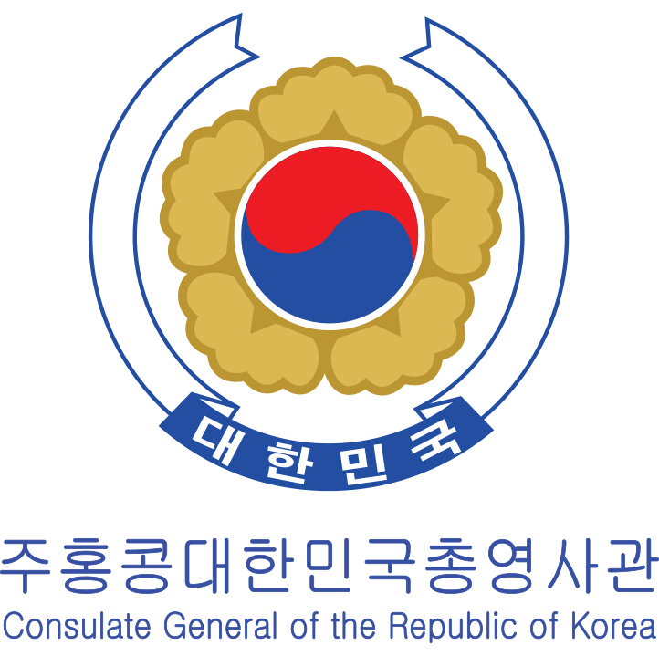



Suite 2611 Office Tower,

Langham Place, 8 Arygle St,

Kowloon, Hong Kong

Tel: 2858 1771 | Fax 2736 6361

[www.cwc.com.co](http://www.cwc.com.co) / info@cwc.com.co

**Press Release**

For Immediate Release

13th October 2015

**“Soul Mate” performed by Korean National Opera in collaboration with Hong Kong Philharmonic Orchestra**

* **Meeting with actors and director: Artistic director of Korea National Opera, director, composer, and actors of “Soul Mate” will come to Hong Kong and meet the press.**
* **Open audition of little actors will perform alongside of professional Korean actors and musicians**

Korean art programmes seem to be unstoppable in this October! After a number of impressive Korean cultural programmes organized by Festive Korea, it has finally come to the highlight of this year’s festival. “Soul Mate”, an unique crossover between Korea National Opera and Hong Kong Philharmonic Orchestra - this large scale performance including 160 actors, singers and musicians on stage will bring you an extraordinary theatre experience.

“Soul Mate”, adapted from the original play “The Joyful Occasion at the Maeng Jin-sa Household”: Two families, the Maeng is the wealthiest and the Kim is the most powerful, want to conduct a political marriage of their children Mongwan and Seohyang, to get what they want. But their children disguise themselves into servants to look for their own true love while not to disrespect their parents.

We have publicly recruited 16 children from 2-5 years old to join the opera team to perform on the stage. Among the children, we have deliberately chosen different nationalities, some of them are Korean children based in Hong Kong, some are local Chinese and some are half Korean and half Chinese. This is an excellent opportunity for the children to participate in international performance and develop a lifelong education to let them expand their horizon.

The Artistic Director of the Opera, director, composer and actors will come to Hong Kong and share their experience. Besides, the Korea cultural consul and well-established Korean culture expert Ms. Paris Moon are willing to discuss about the influence of K-wave in Hong Kong with you further.

Performance details

* Venue: Hong Kong Cultural Centre Grand Theatre
* Date: 30th and 31st October 2015
* Time: 7:30pm
* Ticket Price: 630, 460, 300, 150 (Students, senior citizens and disabled will enjoy 50% off)

If you have any enquiries, please do not hesitate to contact us via phone or email.

Ms. Shannon Choi (English/ Korean)

Ms. Rita Kong (Chinese)

Tel: 28581771 | email: info@cwc.com.co